/*

### A. Customer Journey

***Based off the 8 sample customers provided in the sample from the subscriptions table, write a brief description about each customer’s onboarding journey.***

***Try to keep it as short as possible - you may also want to run some sort of join to make your explanations a bit easier!***

*/

SELECT

s.customer_id,

p.plan_name,

p.price,

s.start_date

FROM subscriptions s

JOIN plans p

ON s.plan_id = p.plan_id

WHERE s.customer_id<=8

ORDER BY s.customer_id, s.start_date;

**RESULT:**

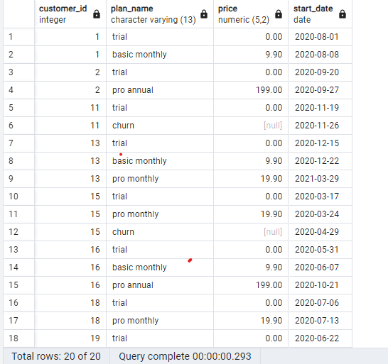

brief descriptions of each customer's onboarding journey:

Customer 1:

Journey: Started with a trial on August 1, 2020, and upgraded to the Basic Monthly plan on August 8, 2020.

Customer 2:

Journey: Began with a trial on September 20, 2020, and quickly switched to the Pro Annual plan on September 27, 2020.

Customer 3:

Journey: Initiated with a trial on January 13, 2020, and moved to Basic Monthly a week later, on January 20, 2020.

Customer 4:

Journey: Started a trial on January 17, 2020, upgraded to Basic Monthly on January 24, 2020, but churned on April 21, 2020.

Customer 5:

Journey: Began with a trial on August 3, 2020, and switched to the Basic Monthly plan a week later, on August 10, 2020.

Customer 6:

Journey: Started a trial on December 23, 2020, upgraded to Basic Monthly on December 30, 2020, and churned on February 26, 2021.

Customer 7:

Journey: Began with a trial on February 5, 2020, quickly moved to Basic Monthly on February 12, 2020, and later upgraded to Pro Monthly on May 22, 2020.

Customer 8:

Journey: Started a trial on June 11, 2020, moved to Basic Monthly on June 18, 2020, and upgraded to Pro Monthly on August 3, 2020.

**B. Data Analysis Questions**

***-- 1. How many customers has Foodie-Fi ever had?***

SELECT COUNT(DISTINCT customer_id) AS total_customers

FROM subscriptions;

**RESULT:**

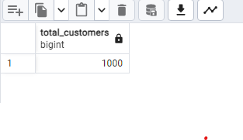

There were 1000 customers

***2.What is the monthly distribution of trial plan start_date values for our dataset - use the start of the month as the group by value.***

SELECT

DATE_TRUNC('month', start_date) AS month_start,

COUNT(*) AS trial_count

FROM

subscriptions

WHERE

plan_id = 0 -- Filter for trial plan (plan_id = 0)

GROUP BY

DATE_TRUNC('month', start_date)

ORDER BY

month_start;

**RESULT:**

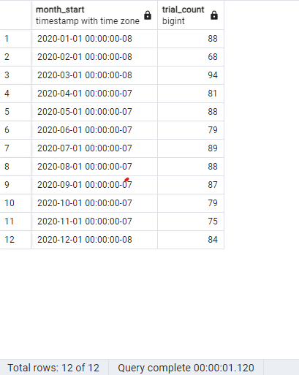

***3. What plan start_date values occur after the year 2020 for our dataset? Show the breakdown by count of events for each plan_name***

SELECT

p.plan_name,

COUNT(*) AS start_count

FROM subscriptions s

JOIN plans p

ON s.plan_id = p.plan_id

WHERE EXTRACT(YEAR FROM start_date)>2020 --OR WHERE start_date>'2020-12-31'

GROUP BY p.plan_name

ORDER BY start_count DESC;

**RESULT:**

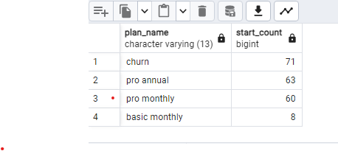

***4. What is the customer count and percentage of customers who have churned rounded to 1 decimal place?***

WITH total_customers AS (

SELECT COUNT(DISTINCT customer_id) AS total_count

FROM subscriptions

),

churned_customers AS (

SELECT COUNT(DISTINCT customer_id) AS churned_count

FROM subscriptions

WHERE plan_id = 4

)

SELECT

c.churned_count,

ROUND((c.churned_count::decimal / t.total_count) * 100, 1) AS churn_percentage

FROM churned_customers c, total_customers t;

**RESULT**

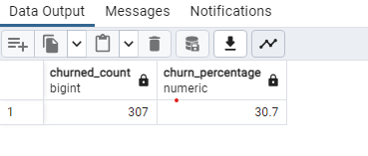

Out of the total customer base of Foodie-Fi, 307 customers have churned. This represents approximately 30.7% of the overall customer count

***5. How many customers have churned straight after their initial free trial - what percentage is this rounded to the nearest whole number?***

WITH plan_cte AS

(

SELECT customer_id,

plan_name,

ROW_NUMBER()OVER (PARTITION BY customer_id ORDER BY start_date)AS rnk

FROM subscriptions s

INNER JOIN plans p

ON s.plan_id=p.plan_id

)

SELECT COUNT(DISTINCT customer_id) AS churned_after_trial,

ROUND(100.0*

COUNT(DISTINCT customer_id)/

(SELECT COUNT(DISTINCT customer_id )FROM subscriptions)

) percent_churn_after_trial

FROM plan_cte

WHERE rnk=2

AND plan_name='churn';

**RESULT:**

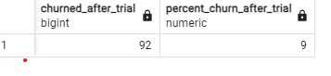

A total of 92 customers churned immediately after the initial free trial period, representing approximately 9% of the entire customer base.

***6. What is the number and percentage of customer plans after their initial free trial?***

Sol1:

WITH plan_cte AS

(

SELECT s.customer_id,s.plan_id,

p.plan_name,

ROW_NUMBER()OVER (PARTITION BY s.customer_id ORDER BY s.start_date)AS rnk

FROM subscriptions s

INNER JOIN plans p

ON s.plan_id=p.plan_id

)

SELECT

plan_id,plan_name,

COUNT(DISTINCT customer_id) convert_count,

ROUND(100*

COUNT(customer_id)::NUMERIC/

(SELECT COUNT(DISTINCT customer_id )FROM subscriptions),1

) convert_percent

FROM plan_cte

WHERE rnk=2

GROUP BY plan_name,plan_id

ORDER BY plan_id;

**RESULT:**

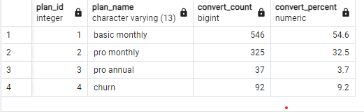

Sol2:using LEAD()

WITH next_plans AS (

SELECT

customer_id,

plan_id,

LEAD(plan_id) OVER(

PARTITION BY customer_id

ORDER BY plan_id) as next_plan_id

FROM subscriptions

)

SELECT

n.next_plan_id ,

COUNT(n.customer_id) AS converted_customers,

ROUND(100 *

COUNT(n.customer_id)::NUMERIC

/ (SELECT COUNT(DISTINCT customer_id)

FROM subscriptions)

,1) AS conversion_percentage

FROM next_plans n

WHERE next_plan_id IS NOT NULL

AND plan_id=0

GROUP BY n.plan_id,next_plan_id

ORDER BY next_plan_id;

**RESULT:**

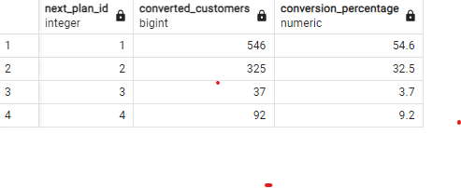

* More than 80% of Foodie-Fi's customers are on paid plans with a majority opting for Plans 1 and 2.
* There is potential for improvement in customer acquisition for Plan 3 as only a small percentage of customers are choosing this higher-priced plan.

***7. What is the customer count and percentage breakdown of all 5 plan_name values at 2020-12-31?***

WITH CTE AS (

SELECT *

,ROW_NUMBER() OVER(PARTITION BY customer_id ORDER BY start_date DESC) as rn

FROM subscriptions

WHERE start_date <= '2020-12-31'

)

SELECT

cte.plan_id,

plan_name,

COUNT(customer_id) as customer_count,

ROUND((COUNT(customer_id)::NUMERIC/(SELECT COUNT(DISTINCT customer_id) FROM CTE))*100,1) as percent_of_customers

FROM CTE

INNER JOIN plans as P on CTE.plan_id = P.plan_id

WHERE rn = 1

GROUP BY cte.plan_id,plan_name

ORDER BY cte.plan_id;

**RESULT:**

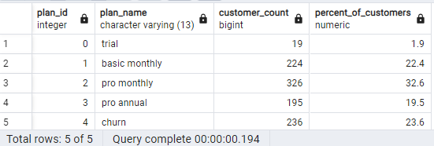

Sol2:

WITH next_dates AS (

SELECT

customer_id,

plan_id,

start_date,

LEAD(start_date) OVER (

PARTITION BY customer_id

ORDER BY start_date

) AS next_date

FROM subscriptions

WHERE start_date <= '2020-12-31'

)

SELECT

plan_id,

COUNT(DISTINCT customer_id) AS customers,

ROUND(100.0 *

COUNT(DISTINCT customer_id)

/ (SELECT COUNT(DISTINCT customer_id)

FROM subscriptions)

,1) AS percentage

FROM next_dates

WHERE next_date IS NULL

GROUP BY plan_id;

RESULT:

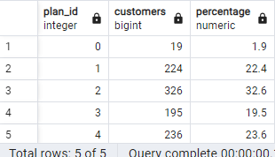

***8. How many customers have upgraded to an annual plan in 2020?***

SELECT p.plan_name,COUNT(s.customer_id)AS count_convert_to_annual

FROM subscriptions s

JOIN plans p

USING(plan_id)

WHERE plan_id=3

AND

EXTRACT(YEAR FROM start_date)=2020

GROUP BY p.plan_name;

**RESULT:**

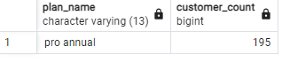

***9. How many days on average does it take for a customer to an annual plan from the day they join Foodie-Fi?***

WITH trial_cte AS

(

SELECT customer_id,start_date AS trial_date

FROM subscriptions

WHERE plan_id=0

),

annual_cte AS

(

SELECT customer_id,start_date AS annual_date

FROM subscriptions

WHERE plan_id=3

)

SELECT

ROUND(AVG(a.annual_date-t.trial_date),0) AS avg_days_to_upgrade

FROM trial_cte t JOIN annual_cte a

USING(customer_id);

**RESULT:**

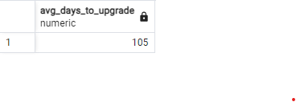On average, customers take approximately 105 days from the day they join Foodie-Fi to upgrade to an annual plan.

***10. Can you further breakdown this average value into 30 day periods (i.e. 0-30 days, 31-60 days etc)***

-- Sol1

WITH trial_cte AS

(

SELECT

customer_id,

MIN(start_date) AS trial_start

FROM subscriptions

WHERE plan_id = 0

GROUP BY customer_id

), annual_cte AS

(

SELECT

s.customer_id,

s.start_date AS annual_start,

(s.start_date - t.trial_start) AS days_to_annual -- Calculate days between trial and annual plan

FROM subscriptions s

JOIN trial_cte t

ON s.customer_id = t.customer_id

WHERE s.plan_id = 3

)

SELECT

(CASE

WHEN days_to_annual <= 30 THEN 1

WHEN days_to_annual <= 60 THEN 2

WHEN days_to_annual <= 90 THEN 3

WHEN days_to_annual <= 120 THEN 4

WHEN days_to_annual <= 150 THEN 5

WHEN days_to_annual <= 180 THEN 6

WHEN days_to_annual <= 210 THEN 7

WHEN days_to_annual <= 240 THEN 8

WHEN days_to_annual <= 270 THEN 9

WHEN days_to_annual <= 300 THEN 10

WHEN days_to_annual <= 330 THEN 11

WHEN days_to_annual <= 360 THEN 12

ELSE 13

END) AS sort_order,

(CASE

WHEN days_to_annual <= 30 THEN '0-30'

WHEN days_to_annual <= 60 THEN '31-60'

WHEN days_to_annual <= 90 THEN '61-90'

WHEN days_to_annual <= 120 THEN '91-120'

WHEN days_to_annual <= 150 THEN '121-150'

WHEN days_to_annual <= 180 THEN '151-180'

WHEN days_to_annual <= 210 THEN '181-210'

WHEN days_to_annual <= 240 THEN '211-240'

WHEN days_to_annual <= 270 THEN '241-270'

WHEN days_to_annual <= 300 THEN '271-300'

WHEN days_to_annual <= 330 THEN '301-330'

WHEN days_to_annual <= 360 THEN '331-360'

ELSE '360+' -- Handles cases where days are more than 360

END) AS bin,

COUNT(customer_id) AS customer_count,

ROUND(AVG(days_to_annual), 1) AS average_days_to_annual

FROM

annual_cte

GROUP BY bin,sort_order

ORDER BY sort_order

;

RESULT:

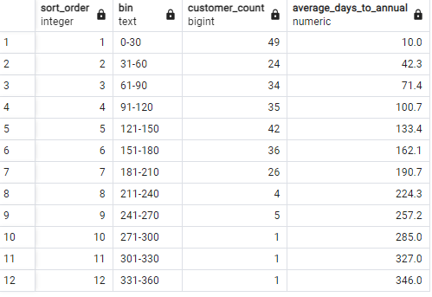

Sol2:

WITH trial_cte AS

(

SELECT customer_id,

MIN(start_date) AS trial_start_date

FROM subscriptions s

WHERE plan_id=0

GROUP BY customer_id

),

annual_cte AS

(

SELECT s.customer_id,

s.start_date AS annual_start_date,

(s.start_date-t.trial_start_date) AS days_to_upgrade

FROM subscriptions s

JOIN trial_cte t

USING(customer_id)

WHERE plan_id=3

)

SELECT

WIDTH_BUCKET(days_to_upgrade,0,365,12) AS bucket,

((WIDTH_BUCKET(days_to_upgrade,0,365,12)-1)*30+1||' - '||WIDTH_BUCKET(days_to_upgrade,0,365,12)*30) AS bin,

COUNT(*) AS customer_count,

ROUND(AVG(days_to_upgrade),1) AS avg_days_to_upgrade

FROM annual_cte a

GROUP BY bin,bucket

ORDER BY Bucket ;

**RESULT:**

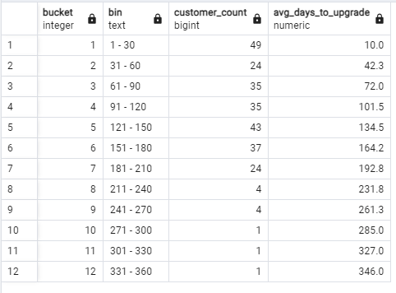

***11. How many customers downgraded from a pro monthly to a basic monthly plan in 2020?***

--Sol1:

WITH pro_monthly_cte As

(

SELECT

customer_id,

start_date AS pro_month_start

FROM subscriptions

WHERE plan_id=2

),

basic_monthly_cte As

(

SELECT

customer_id,

start_date AS basic_month_start

FROM subscriptions

WHERE plan_id=1

)

SELECT

COUNT(DISTINCT p.customer_id) downgrade_count

FROM

pro_monthly_cte p JOIN basic_monthly_cte b

USING(customer_id)

WHERE

p.pro_month_start<b.basic_month_start

AND EXTRACT(YEAR FROM b.basic_month_start)=2020;

**RESULT:**

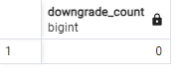

--sol2:

WITH pro_monthly_to_basic AS (

-- Find customers who switched from pro monthly to basic monthly

SELECT

s1.customer_id,

s1.start_date AS pro_monthly_start,

s2.start_date AS basic_monthly_start

FROM subscriptions s1

JOIN subscriptions s2

ON s1.customer_id = s2.customer_id

WHERE

s1.plan_id = 2 -- Pro monthly

AND s2.plan_id = 1 -- Basic monthly

AND s1.start_date < s2.start_date -- Downgrade event: pro monthly must occur before basic monthly

AND EXTRACT(YEAR FROM s2.start_date) = 2020 -- Limit to downgrades in 2020

)

SELECT

COUNT(DISTINCT customer_id) AS downgrade_count

FROM pro_monthly_to_basic;

**RESULT:**



-- sol3

WITH pro_to_basic_cte AS (

SELECT

s.customer_id,

p.plan_id,

p.plan_name,

LEAD(p.plan_id) OVER (

PARTITION BY s.customer_id

ORDER BY s.start_date) AS next_plan_id

FROM subscriptions AS s

JOIN plans AS p

ON s.plan_id = p.plan_id

WHERE EXTRACT(YEAR FROM s.start_date) = 2020

)

SELECT

COUNT(customer_id) AS downgraded_customers

FROM pro_to_basic_cte

WHERE plan_id = 2

AND next_plan_id = 1;

RESULT:

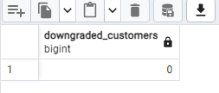

In 2020, there were no instances where customers downgraded from a pro monthly plan to a basic monthly plan.

**/*C. Challenge Payment Question**

***The Foodie-Fi team wants you to create a new payments table for the year 2020***

***that includes amounts paid by each customer in the subscriptions table with***

***the following requirements:***

***monthly payments always occur on the same day of month as the original start_date of any monthly paid plan***

***upgrades from basic to monthly or pro plans are reduced by the current paid amount in that month and start immediately***

***upgrades from pro monthly to pro annual are paid at the end of the current billing***

***period and also starts at the end of the month period once a customer churns they will no longer make payments***

***Example outputs for this table might look like the following:***

***customer_id plan_id plan_name payment_date amount payment_order*/***

-- Create the payments table for 2020

WITH payment_schedule AS -- Identify all subscription changes for customers in 2020

(

SELECT s.customer_id,

s.plan_id,

p.plan_name,

p.price,

s.start_date,

LEAD(s.start_date) OVER (PARTITION BY s.customer_id ORDER BY s.start_date) AS next_plan_start_date,

p.plan_name='churn' AS has_churned

FROM subscriptions s

JOIN plans p

USING(plan_id)

WHERE EXTRACT(YEAR FROM s.start_date)=2020

),

payment_calender AS -- Generate the payment calendar for all customers, taking into account their plan changes

(

SELECT

ps.customer_id,

ps.plan_id,

ps.plan_name,

ps.start_date AS payment_date,

ps.price AS amount,

ROW_NUMBER() OVER(PARTITION BY ps.customer_id ORDER BY ps.start_date) AS payment_order

FROM payment_schedule ps

WHERE NOT ps.has_churned --exclude churned

UNION ALL -- Handle monthly payments until the customer changes plans or churns

SELECT ps.customer_id,

ps.plan_id,

ps.plan_name,

ps.start_date + INTERVAL '1 month' * generate_series(1, CAST(DATE_PART('month', AGE(COALESCE(next_plan_start_date, '2020-12-31'), ps.start_date)) AS INTEGER)) AS payment_date,

ps.price AS amount,

ROW_NUMBER() OVER(PARTITION BY ps.customer_id ORDER BY ps.start_date + INTERVAL '1 month' * generate_series(1, CAST(DATE_PART('month', AGE(COALESCE(next_plan_start_date, '2020-12-31'), ps.start_date)) AS INTEGER)))AS payment_order

FROM payment_schedule ps

WHERE ps.plan_name IN('basix monthly','pro monthly')

)

-- create the payments table for 2020

SELECT

customer_id,

plan_id,

plan_name,

payment_date,

amount,

payment_order

FROM payment_calender

WHERE

EXTRACT(YEAR FROM payment_date) = 2020

ORDER BY customer_id, payment_order;

**RESULT:**

